Working with INPE-EM

A user's guide

Version 4.0 | August 2020



Working with INPE-EM

A user's guide

Version 4.0 | September 2020

 Lead authors: INPE-EM Team



Contents

1 Introducing the INPE-EM 4

1.1 What is INPE-EM 4

2 Getting started with INPE-EM 8

2.1 Installing INPE-EM 8

3 Building a INPE-EM model 9

3.1 Introduction 9

3.2 Configuring the Model Parameters 9

3.2.1 Model Definitions 9

3.2.2 Components 9

3.2.2.1 Biomass 10

3.2.2.2 Deforest 11

3.2.2.3 Primary Vegetation 11

3.2.2.4 Secondary Vegetation 14

3.2.2.5 Degradation 15

3.3 Non Spatial Model 17

3.3.1 Non Spatial Data Table 17

3.3.2 Components Selection 18

3.4 Spatial Model 18

3.4.1 File 19

3.4.2 Components Selection 19

3.5 Files Maker 20

3.6 Run Model 21

3.7 Spatial Model Outputs 21

References 23

# Introducing the INPE-EM

## What is INPE-EM

INPE-EM is a product of the Earth System Science Center (CCST) of the National Institute for Space Research (INPE), in partnership with several institutions. The estimates are computed using the generic INPE-EM modeling framework for emissions modeling (Aguiar et al., 2012, Aguiar et al. 2016, Assis et al., 2020), which combines spatially explicit maps of biomass and deforestation for a study area. The main feature of INPE-EM framework is flexibility in representing the emission processes, enabling refinement of the estimates according to the data available:

* Data is organized into regular cells; whose resolution depends on the biomass and deforestation maps available in a particular region.
* The framework allows both estimates of 1st Order (assuming 100% of the emissions occur at the time of the land cover transition), and estimates of 2nd Order (to consider the gradual process of liberation and carbon sequestration, representing flows between biomass compartments).
* All parameters that represent the process of emission/absorption (for estimates of 1st and 2nd Order) may be spatially explicit about considering the heterogeneity within a region (e.g., the emission factors).
* Finally, the framework is easily configurable, extensible, and open-source, allowing the development of new modules or modifications to the existing ones whenever necessary. The modeling framework INPE-EM is developed in TerraME modeling environment.

The initial version of the framework, described in Aguiar et al. (2012), consisted of adapting the model "bookkeeping" proposed by Houghton et al. (2000) to a spatially explicit environment. The initial version of the framework represented the process of clear-cut deforestation in tropical forest areas and the subsequent dynamics of the secondary vegetation in those deforested areas. Several improvements have been incorporated into the framework recently. New parameters have been introduced to make it more suitable to represent the different practices adopted for removing the vegetation in different regions and types of vegetation so that new applications for other Biomes could be developed (for instance, partial removal of the roots). Carbon pools related to the dead organic matter (deadwood and litter) were explicitly incorporated, being added to the dead organic matter generated by the deforestation process. In addition to estimates of CO2 emissions are also calculated emissions of CH4, N2O, CO, and NOx. Besides, a component was developed that accounts for the emission/absorption by forest degradation and regrowth of vegetation in the degraded area.

These estimates are now presented in an aggregate form (tables with annual totals) and also in a spatially disaggregated way in regular cells (maps). The figure below shows how we estimate the 1st and 2nd Order emissions in the initial version of the framework, which consider the gradual process of carbon release and absorption, representing the flows between the biomass pools). All parameters that represent the emission/absorption processes (for 1st and 2nd order estimates) can be spatially explicit, making it possible to represent spatial heterogeneity within a region (for example, emission factors).

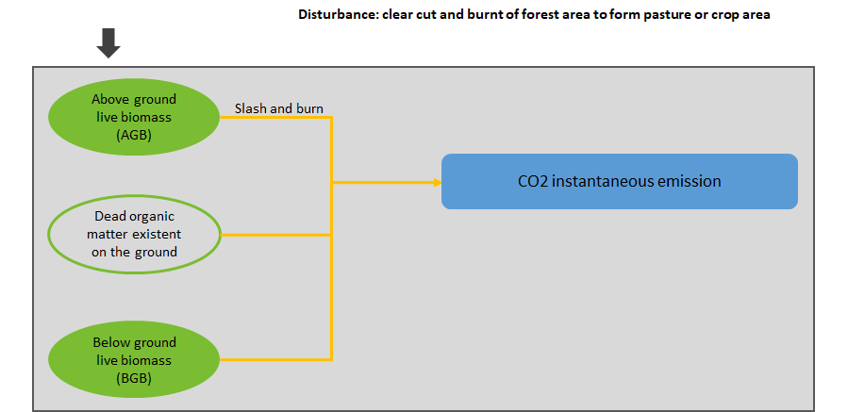

Figure 1 – Estimation of 1st order emission.

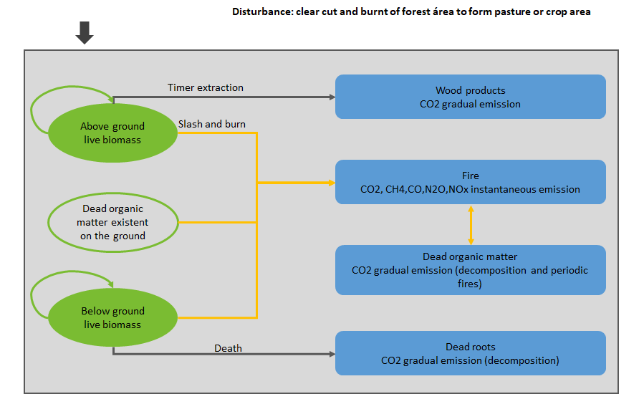

Figure 2 – Estimation of 2nd order emission.

Estimates of 2nd order aim at representing more realistically the carbon release rate into the atmosphere over time - taking into account that part of the biomass is converted into wood products, part is burned, and part is left on the ground, suffering gradual decomposition field (above or below ground). On the other hand, 1st order estimates assumed the instantaneous release of 100% of the carbon above and below ground. In the case of CO2, emissions of 2nd Order consider the sum of components related to instantaneous release by burning (the living biomass and dead organic matter) to the gradual decomposition of elements of dead organic matter, wood products, and elemental carbon. Emissions of CH4, N2O, CO, and NOx are proportional only to the percentage of biomass burned.

INPE-EM 4.0 presents a new component to estimate greenhouse emissions due to forest degradation. This component refines the degradation component available in version 3.1, which was the first attempt to incorporate forest degradation emissions into the estimates of clear cut and secondary vegetation of INPE-EM. This component biomass in each cell is dynamically updated as the result of subsequent forest degradation events (fires, selective logging), post-event regeneration. The biomass stock in a cell increases or decreases according to its degradation trajectory, and the model calculates the corresponding emission/absorption. When a clear cut occurs in the cell, the model estimates the emission corresponding to this current stock of biomass. The version of the forest degradation component available in component 4.0 allows the user to set a variable rate of regrowth over the years, allowing the adoption of regrowth curves that represent the process in a more realistic way, along the lines of 2nd Order emissions.

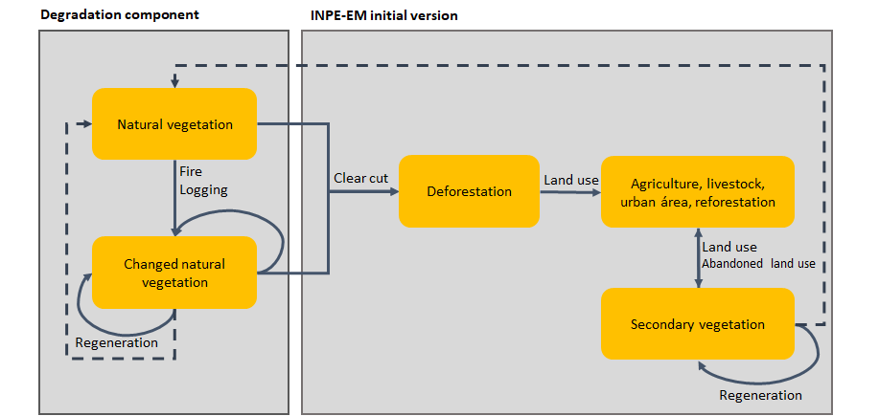

Figure 3 – Degradation Component.

# Getting started with INPE-EM

This chapter describes how to get started with INPE-EM 3.1.

## Installing INPE-EM

To use INPE-EM, you only need to download the installer, available at <http://inpe-em.ccst.inpe.br>, then run the installation file (64-bit).

# Building a INPE-EM model

## Introduction

The construction of an INPE-EM model can be divided into two steps. The first step is to prepare the input data, either the table(s) of the non-spatial model and the spatial model database.

For more information on the spatial database, it is recommended that you read the LuccME User Guide, where the entire creation process is covered, available at <http://luccme.ccst.inpe.br/documentacao-e-exemplos/>.

The second step is to parameterize the model, which will be described in detail later in this chapter.

## Configuring the Model Parameters

In the next sessions, all the parameters of an INPE-EM 3.1 model will be explained.

### Model Definitions

The parameters related to the model settings are:

Folder to Save the Model: Location where the generated files will be saved.

Model Name: This name will be used in the generation of the model files *(.lua)*, if selected, will also be the name of the combined model.

### Components

The INPE-EM available components are found in this session. They must be parameterized to be used in the model.

Important: The values entered in the components will always be used for non-spatial model calculations. In the spatial model, if the variable exists in the database, the value of the database will be used. Otherwise, the value entered in the component will be used in the calculation. Example: If the variable b2_agb[1] exists in the spatial database, it will be used. Otherwise, the value entered in averAGB in the biomass component will be used.

#### Biomass

Through the biomass component, we inform the model of biomass data; this component is mandatory for any model and must always be parameterized.

In the graphic interface, we have the following parameters:

Name: name of the biomass component. It must have a maximum of two characters and will be used in the composition of the name of the spatial data.

Description: field to provide some description of the component.

averAGB: above ground biomass, considering only the forestry biomass.

averBGBPercAGB: percentage of below ground biomass in relation to above ground live biomass.

averLitterPercAGB: percentage of litter in relation to above ground live biomass.

averDeadWoodPercAGB: percentage of dead wood biomass in relation to above ground live biomass.

averFactorB_C: biomass conversion factor for carbon.

averFactorB_CO2: biomass conversion factor for CO2 from decay.

averFactorB_CO2_fire: biomass conversion factor for CO2 from burning.

averFactorB_CH4_fire: biomass conversion factor for CH4 from burning.

averFactorB_N2O_fire: biomass conversion factor for N2O from burning.

averFactorB_NOx_fire: biomass conversion factor for NOx from burning.

averFactorB_CO_fire: biomass conversion factor for CO from burning.

In the spatial database, the parameters must be named as follows, <component name><spatial variable>, example: b2_agb.

The variables available in the spatial database are:

_agb: above ground biomass, considering only the forestry biomass.

_perc1: percentage of below ground biomass in relation to above ground live biomass.

_perc2: percentage of litter in relation to above ground live biomass.

_perc3: percentage of dead wood biomass in relation to above ground live biomass.

#### Deforest

In the deforestation component we inform the model of deforestation values, this is also a mandatory component for any type of model.

In the graphic interface we have the following parameters:

Name: name of the biomass component. It must have a maximum of two characters and will be used in the composition of the name of the spatial data.

Description: field to provide some description of the component.

initalArea: cumulative Area of deforestation up to the initial year of the non spatial model.

initalForest: forest area on the initial year of the non spatial model.

In the spatial database, the parameters must be named as follows, <component name>_inita, example: d_inita; or, <component name>_area<data year (YY)>, example: d_area08.

The variables available in the spatial database are:

_inita: cumulative Area of deforestation up to the initial year of the non spatial model.

_forest: forest area on the initial year of the spatial model.

_area: increase in deforested Area in each year of the model.

#### Primary Vegetation

The Primary Vegetation component provides emission estimates of 1st Order (assuming the simplification that 100% of the carbon is released at the time of the land cover change) and 2nd Order (which represents the temporal process of carbon emission, combining instantaneous release by fire and gradual biological decomposition).

For details of how the component was implemented, we recommend reading *"Primary forest component"* in Aguiar et al., 2012, available at:

<http://onlinelibrary.wiley.com/doi/10.1111/j.1365-2486.2012.02782.x/full>

In the graphic interface we have the following parameters:

Name: name of the primary vegetation component. It must have a maximum of two characters and will be used in the composition of the name of the spatial data.

Description: field to provide some description of the component.

averAGBPercAGB: percentage of AGB that remains alive.

averAGBPercWoodProducts: percentage of AGB that turns product timber.

averAGBPercInstantaneous: percentage of AGB that will release carbon from burning.

averAGBPercDecomposition: percentage of AGB that will release carbon from decomposition.

averBGBPercBGB: percentage of BGB that remains alive.

averBGBPercInstantaneous: percentage of BGB that will be removal and release carbon from burning.

averBGBPercDecompositionAbove: percentage of BGB that will be removal and release carbon from above ground decomposition.

averBGBPercDecompositionUnder: percentage of BGB that will be removal and release carbon from below ground decomposition.

DecompositionFireCyclePeriod: number of years to burn residue left on the ground.

DecompositionPercElementalCarbon: percentage of carbon that will be decomposed very slowly in form of elemental carbon.

averLitterPercInstantaneous: percentage of litter that will release carbon from burning.

averLitterPercDecomposition: percentage of litter that will release carbon from decomposition.

averDeadWoodPercInstantaneous: percentage of dead wood that will release carbon from burning.

averDeadWoodPercDecomposition: percentage of dead wood that will release carbon from decomposition.

averDecayRateWoodProducts: decay rate of wood products.

averDecayRateElementalCarbon: decay rate of above ground biomass that will be decomposed very slowly in form of elemental carbon.

averDecayRateAGBDecomposition: decay rate of above ground biomass.

averDecayRateBGBDecompositionAbove: decay rate of below ground biomass that will release carbon from above ground decomposition.

averDecayRateBGBDecompositionUnder: decay rate of below ground biomass that will release carbon from below ground decomposition.

averDecayRateLitterDecomposition: decay rate of litter by decomposition.

averDecayRateDeadWoodDecomposition: decay rate of dead wood by decomposition.

In the spatial database, the parameters must be named as follows, <component name><spatial variable>, example: vr_agb1.

The variables available in the spatial database are:

_ agb1: percentage of AGB that remains alive.

_ agb4: percentage of AGB that turns product timber.

_ agb3: percentage of AGB that will release carbon from burning.

_ agb2: percentage of AGB that will release carbon from decomposition.

_bgb1: percentage of BGB that remains alive.

_ bgb4: percentage of BGB that will be removal and release carbon from burning.

_bgb2: percentage of BGB that will be removal and release carbon from above ground decomposition.

_ bgb3: percentage of BGB that will be removal and release carbon from below ground decomposition.

_ dec2: number of years to burn residue left on the ground.

_ dec1: percentage of carbon that will be decomposed very slowly in form of elemental carbon.

_ lit2: percentage of litter that will release carbon from burning.

_ lit1: percentage of litter that will release carbon from decomposition.

_ dw2: percentage of dead wood that will release carbon from burning.

_dw1: percentage of dead wood that will release carbon from decomposition.

_ dr7: decay rate of wood products.

_ dr5: decay rate of above ground biomass that will be decomposed very slowly in form of elemental carbon.

_ dr1: decay rate of above ground biomass.

_ dr2: decay rate of below ground biomass that will release carbon from above ground decomposition.

_ dr3: decay rate of below ground biomass that will release carbon from below ground decomposition.

_ dr6: decay rate of litter by decomposition.

_ dr4: decay rate of dead wood by decomposition.

#### Secondary Vegetation

This component of the model represents different paths in secondary vegetation dynamics using spatially distributed parameters, depending on land use practices (Ramankutty et al., 2007).

For details of how the component was implemented, we recommend reading *“Secondary growth component”* in Aguiar et al., 2012, available at:

<http://onlinelibrary.wiley.com/doi/10.1111/j.1365-2486.2012.02782.x/full>

In the graphic interface we have the following parameters:

Name: name of the secondary vegetation component. It must have a maximum of two characters and will be used in the composition of the name of the spatial data.

Description: field to provide some description of the component.

averHalfLife: number of years required for 50% of secondary vegetation (after identification in remote sensing images) is cut, according to an exponential curve.

averAreaPercVegSec: percentage of deforested Area that will be converted in secondary vegetation.

averAreaAccPercVegSec: percentage of cumulative deforested Area that will be converted in secondary vegetation.

averRecoveryPeriod1Perc: percentage of original biomass recovered in the period 1.

averRecoveryPeriod1: growth time of period 1 in years.

averRecoveryPeriod2Perc: percentage of original biomass recovered in the period 2.

averRecoveryPeriod2: growth time of period 2 in years.

averAgriculturalUseCycle: number of years for the Area in agricultural use is abandoned or set aside, after deforestation.

averInitialAbandonmentCycle: number of years of abandonment before a secondary vegetation area can be identified in remote sensing images.

In the spatial database, the parameters must be named as follows, <component name><spatial variable>, example: sv_hl.

The variables available in the spatial database are:

_hl: number of years required for 50% of secondary vegetation (after identification in remote sensing images) is cut, according to an exponential curve.

_apvs: percentage of deforested Area that will be converted in secondary vegetation.

_aapvs: percentage of cumulative deforested Area that will be converted in secondary vegetation.

_rp1p: percentage of original biomass recovered in the period 1.

_rp1: growth time of period 1 in years.

_rp2p: percentage of original biomass recovered in the period 2.

_rp2: growth time of period 2 in years.

_auc: number of years for the Area in agricultural use is abandoned or set aside, after deforestation.

_iac: number of years of abandonment before a secondary vegetation area can be identified in remote sensing images.

#### Degradation

This component considers forest degradation as a process that results in "canopy thinning and carbon loss in the remaining forests, where damage is not associated with a change in land use and where, if not prevented, the forest is expected grow" (Hosonuma et al., 2012).

For details of how the component was implemented, we recommend reading of the following articles:

* Appendix 4 of Aguiar et al., 2016, available at:

<http://onlinelibrary.wiley.com/store/10.1111/gcb.13134/asset/supinfo/gcb13134-sup-0004-AppendixS4.pdf?v=1&s=b252c13e82945faf4b7fd789212788bd84bee577>

* Assis et al., 2020, available at:

<https://iopscience.iop.org/article/10.1088/1748-9326/ab9cfc/meta>

In the graphic interface we have the following parameters:

Name: name of the secondary vegetation component. It must have a maximum of two characters and will be used in the composition of the name of the spatial data.

Description: field to provide some description of the component.

averAGB_loss: percentage of AGB lost as result of the event.

averBGB_loss: percentage of BGB lost as result of the event.

averDeadWood_loss: percentage of dead wood lost as result of the event.

averLitter_loss: percentage of litter lost as result of the event.

averPeriodRegrow: number of years to recuperate the lost biomass.

Regrow Rate: table containing the percentage of biomass regrowth per year. If the checkbox is not selected, INPE-EM assumes a fixed regrowth rate, given by the amount of biomass lost divided by the number of years for its recovery (averPeriodRegrow).

In the spatial database, the parameters must be named as follows, <component name>_darea<data year (YY)>, example: dg_darea08, the other ones, <component name><spatial variable>, example: dg_loss1.

The variables available in the spatial database are:

_darea: the Area identified as degraded that year by fire/logging events (ha).

_loss1: percentage of AGB lost as result of the event.

_loss2: percentage of BGB lost as result of the event.

_loss3: percentage of dead wood lost as result of the event.

_loss4: percentage of litter lost as result of the event.

_pr: number of years to recuperate the lost biomass.

## Non Spatial Model

For the time period which only non-spatial deforestation rates are available, we use the INPE-EM Non-Spatial Model. The non-spatial model is equivalent to using a regular grid composed of a single cell.

To use a non-spatial model, it must be parameterized in the interface. When generating the files, the options Non-Spatial Model and Combined Model will use the non-spatial model.

In the graphic interface we have the following parameters:

Name of Non Spatial Model: name of Non Spatial Model: Name that will be used to represent the non-spatial model inside the template script and its output a file with the same information from the result screen after the run: *<name>*_results.txt.

Initial Year: initial year of simulation.

Final Year: final year of simulation.

Total Area: should be provided the total Area in hectares (ha) of the region to be simulated.

### Non Spatial Data Table

Deforestation, half-life and degradation data in non-spatial model should be reported in table format:

Area: the increase of deforested Area must be informed year by year of.

Half Life: number of years required for 50% of secondary vegetation (after identification in remote sensing images) is cut, according to an exponential curve.

Degradation: the increment of degraded Area must be informed year by year.

Tables must be filled according to the model's needs, for example, if the degradation component is not used in the model, the degradation table does not have to be filled.

### Components Selection

The components available in INPE-EM are listed in Non-Spatial Model, and the user must select the components that will be used in his model. Remember that the selected components need to be parameterized.

As discussed earlier, the biomass component is mandatory, so it must always be parameterized and cannot be unchecked.

Today, the available components are:

* Biomass
* Deforest
* Vegetation Removal
* Secondary Vegetation
* Degradation

The model output will be compatible with the components selection, that is, different components selections in the model, will have different outputs *(columns in the table)*.

## Spatial Model

The Spatial Model requires a geographic database composed of regular cells on a spatial scale suitable for the study area application. This model is applicable for the period of time when spatially explicit data are available *(biomass, deforested Area and/or degradation)*, whether real or projected - to allow the analysis of future scenarios when necessary. The spatial database should contain information on the increment of deforest area for each cell each year, the average biomass above the soil of each cell and other necessary parameters that describe the heterogeneity of the region. Emissions are calculated for a given year for each cell and the total emission is given by the sum of all cells.

In the graphic interface we have the following parameters:

Name of Spatial Model: name that will be used to represent the spatial model inside the template script and its output a file with the same information from the result screen after the run: *<name>*_results.txt.

Initial Year: initial year of simulation.

Final Year: final year of simulation.

### File

You should select the option that best suits you to select your spatial database:

Terraview Project: if you have a Terraview project already created with your cellular space and you want to use it, you must select the *.tview* file using the Select button under Terraview Project.

Shape: if the cellular space is in a Shapefile format, the user should select the *.shp* file using the Select button under Shape.

Layer Name: if the user chooses to use a *.tview* file, it must inform in which Layer contained the cellular space. If the *.shp* option is chosen, the Layer is automatically populated.

Cell Size: Area of the cell in hectares *(ha)*.

For the construction of the spatial database we recommend the use of FillCell tool available in: <http://luccme.ccst.inpe.br/fillcell/>.

### Components Selection

The components available in INPE-EM are listed in Non-Spatial Model, and the user must select the components that will be used in his model. Remember that the selected components need to be parameterized.

As discussed earlier, the biomass component is mandatory, so it must always be parameterized and cannot be unchecked.

Today, the available components are:

* Biomass
* Deforest
* Vegetation Removal
* Secondary Vegetation
* Degradation

The model output will be compatible with the components selection, that is, different components selections in the model, will have different outputs *(columns in the table)*.

To generate spatial output files *(.shp)* the Save to File option must be selected on each component, the components that has this option is: Primary Vegetation, Secondary Vegetation, and Degradation. A file for each component that you want to save the output, will be generated as following: *<Spatial Model Name>_<Component Name>.shp*.

## Files Maker

In this session the user must select which type of model will be used:

* Non Spatial Model – the files with the non spatial model will be generated.
* Spatial model – the files with the spatial model will be generated.
* Combine Model – the files will be generated with the non-spatial and spatial models.

After generating the files, the button to run the model will appear, simply click it to run the model.

In the Combined Model, the values of the non-spatial model, the spatial model values and a combined result will be displayed:

1. <Model Name>_results.txt , with the combine results.
2. <Non Spatial Model Name>_results.txt , with the non spatial model results.
3. <Spatial Model Name >_results.txt , with the spatial model results.

When using the combined model, the simulation end years of both the non-spatial model and the spatial model must be the same. In the interval in which the simulation years of the two models coincide, the values in the non-spatial model must be zeroed so as not to be computed in duplicate and added together later.

## Run Model

If the model’s files were generated correctly or the model was opened correctly, and the files are in the correct addresses, the Run Model button is available in Files Maker tab.

To execute the model just click on Run Model button.

After the model has finished running, the generated *.txt* files will be available in the same folder where the scripts were generated; the spatial files *(.shp or postgres)*, if applied, will be available in the same place where the incoming cellular space is.

## Spatial Model Outputs

To generate spatial output files *(.shp)* the Save to File option must be selected on each component, the components that has this option is: Primary Vegetation, Secondary Vegetation, and Degradation. A file for each component that you want to save the output, will be generated as following: *<Spatial Model Name>_<Component Name>.shp*.

In the Primary Vegetation component, the columns of the output file will be:

Original data: all input columns will be preserved.

vCO2_<year>: second order value of CO2 emission per clear cut in a given year. E.g.: vCO2_2017.

vCO2f_<year>: second order value of CO2 emission per fire in a given year.

vCH4_<year>: second order value of CH4 emission per clear cut in a given year.

vN2O_<year>: second order value of N2O emission per clear cut in a given year.

vCO_<year>: second order value of CO emission per clear cut in a given year.

vNOx_<year>: second order value of NOx emission per clear cut in a given year.

v1CO2_<year>: first order value of CO2 emission per clear cut in a given year.

In the Secondary Vegetation component, the columns of the output file will be:

Original data: all input columns will be preserved.

OutAVS<year>: Area of secondary vegetation in a given year. Ex.: OutAVS2017.

OutAGR<year>: cumulative Area of secondary vegetation in a given year.

sCO2_<year>: value of CO2 emission in an area of secondary vegetation in a given year.

sICO2_<year>: value of CO2 absorption in secondary vegetation area in a given year.

In the Degradation component, the columns of the output file will be:

Original data: all input columns will be preserved.

dAGB_<year>: biomass in a given year. Ex.: dAGB_2017.

Count_<year>: number of years that degradation has occurred (adding up <year>).

dCO2_<year>: value of CO2 emission in degradation area in a given year.

dCH4_<year>: value of CH4 emission in degradation area in a given year.

dN2O_<year>: value of N2O emission in degradation area in a given year.

dCO_<year>: value of CO emission in degradation area in a given year.

dNOx_<year>: value of NOx emission in degradation area in a given year.

dICO2_<year>: value of CO2 absorption in degradation area in a given year.

# References

AGUIAR, A.P.D. Modeling land use change in the Amazon: Exploring intra-regional heterogeneity. 2006. 153 p. (INPE- 08.10.18.21-TDI). Thesis (Doctoral in Remote Sensing) - Brazilian National Institute for Space Research (INPE), São José dos Campos, 2006. Retrieved from: <http://urlib.net/6qtX3pFwXQZGivnJSY/M7t7e>.

AGUIAR, A. P. D., OMETTO, J. P., NOBRE, C., LAPOLA, D. M., ALMEIDA, C., VIEIRA, I. C., SOARES, J. V., ALVALA, R., SAATCHI, S., VALERIANO, D. AND CASTILLA-RUBIO, J. C. (2012), Modeling the spatial and temporal heterogeneity of deforestation-driven carbon emissions: the INPE-EM framework applied to the Brazilian Amazon. Glob Change Biol, 18: 3346–3366. doi:10.1111/j.1365-2486.2012.02782.x

AGUIAR, A. P. D., VIEIRA, I. C. G., ASSIS, T. O., DALLA-NORA, E. L., TOLEDO, P. M., OLIVEIRA SANTOS-JUNIOR, R. A., BATISTELLA, M., COELHO, A. S., SAVAGET, E. K., ARAGÃO, L. E. O. C., NOBRE, C. A. AND OMETTO, J. P. H. (2016), Land use change emission scenarios: anticipating a forest transition process in the Brazilian Amazon. Glob Change Biol, 22: 1821–1840. doi:10.1111/gcb.13134

ASSIS, T. O.; DE AGUIAR, A. P. D.; VON RANDOW, C.; DE PAULA GOMES, D. M.; KURY, J. N.; OMETTO, J.; NOBRE, C. A. CO2 emissions from forest degradation in Brazilian Amazonia. Environmental Research Letters, 2020.

HOUGHTON, R. A, SKOLE, D. L, NOBRE, C. A, HACKLER, J. L, LAWRENCE, K. T, CHOMENTOWSKI, W. H (2000) Annual fluxes or carbon from deforestation and regrowth in the Brazilian Amazon. Nature, 403, 301–304.

RAMANKUTTY, N, GIBBS, H. K, ACHARD, F, DEFRIES, R, FOLEY, J. A, HOUGHTON, R. A (2007). Challenges to estimating carbon emissions from tropical deforestation. Global Change Biology, 13,51–66.

1. b2 is the name of the biomass component, _agb is the name of the biomass variable.